BQ29209 breakout board Testing log

10/9/17

Initial inspection of board on delivery:

* Found error in board and schematic! R_cb is connected to wrong, It should not go to ground. The error comes from this:

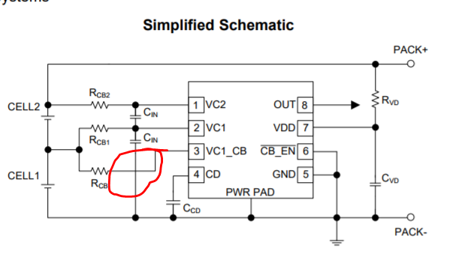

The schematic from the datasheet has the Cin ground passing over the Rcb pin. While the board schematic has them connected:

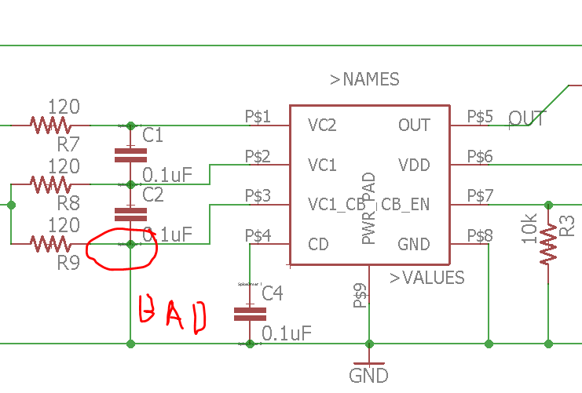

To fix the board the following needs to happen: (next page)

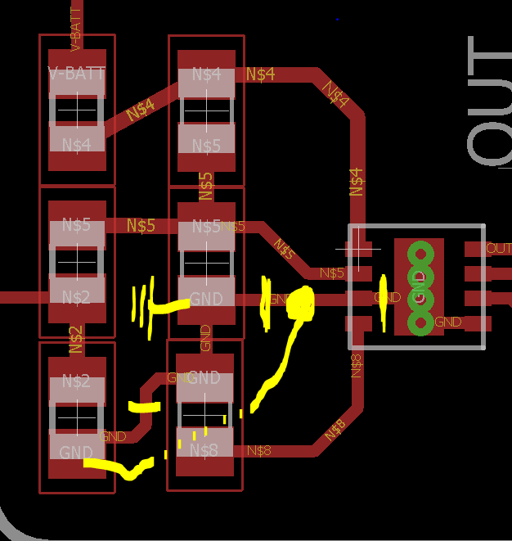

* The Traces need to be cut along the yellow slashes. Which includes:
  + Pin 3’s connection to the ground pad.
  + The capacitor’s connection to Pin 3.
  + And R_cb’s connection to the capacitor’s ground.
* R_CB needs to be connected to pin 3 along the yellow path.
* The capacitor’s need to be connected to ground.